

Faculty of engineering

Chemical Engineering Department

Third Stage (2024-2025)

Reactor Design Laboratory

**(Service unit and Control interface)**

**Prepared by:** Rezhin Rzgar Taha, Dhuha Luqman, Muhammed kazim, Ali Hiwa

**Supervised by:** Mr.Blnd Zrar

Contents

The Aim of this Experiment: 3

Introduction 4

Equipment 5

Control interface 7

Service unit 8

# The Aim of this Experiment:

To determine service unit and control interface connection.

# Introduction

An Electronic Interface refers to a digital platform that provides control and access to data through application programming interfaces or similar methods, adhering to a standard protocol approved by the Commission. This includes the latest version of Green Button Connect My Data sanctioned by NAESB, along with associated best practices, or any competing standard that offers comparable functionality. It enables automated customer authentication and authorization for sharing billing information, including Historical Interval Usage and Interval Usage, with a Supplier, Curtailment Service Provider, or Energy Consultant.

Additionally, an Electronic Interface is a secure IT platform, portal, exchange network, or similar system managed by or on behalf of the Minister, which necessitates personal login credentials for access.

# Equipment

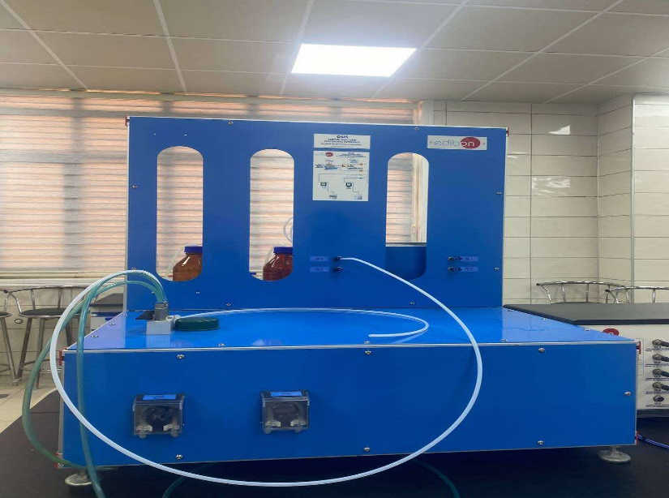

Figure 1 Service unit

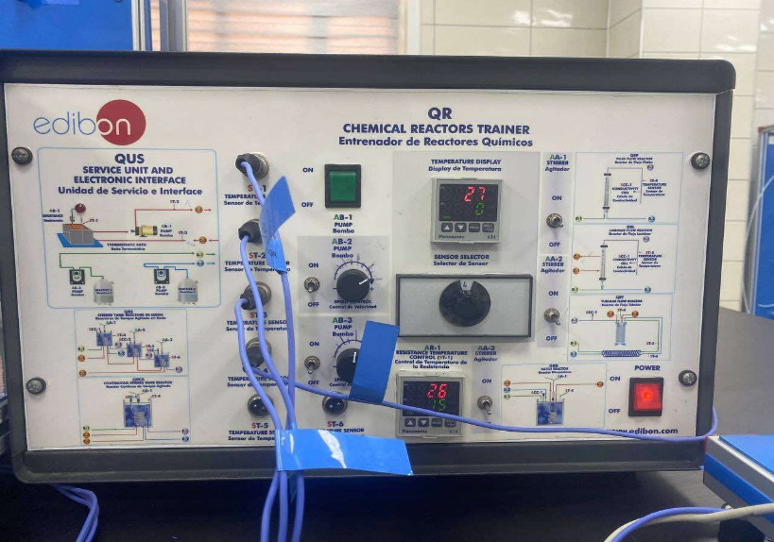

Figure 2Control interface

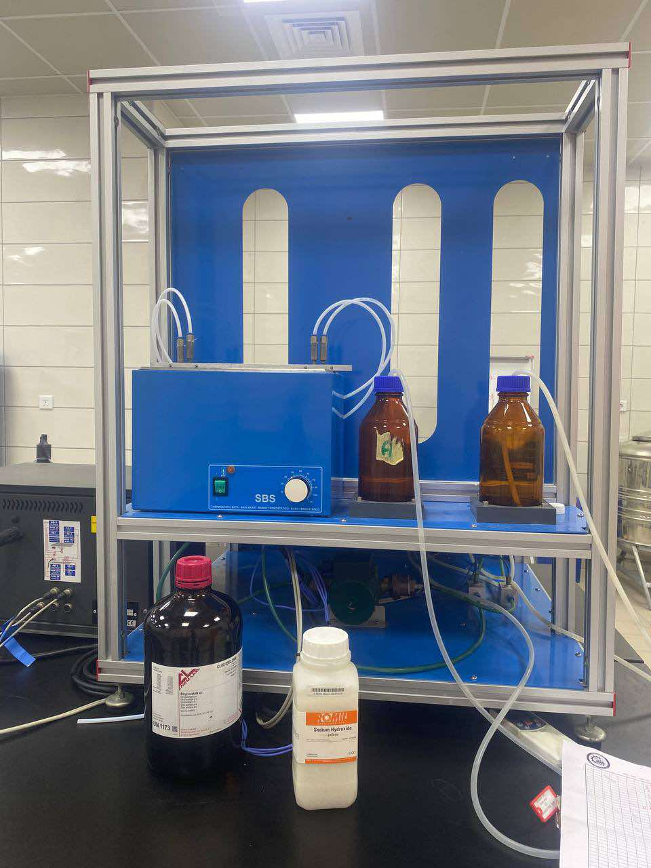

Figure 3Distillated water and solution of (NaOH+CH3COOH)

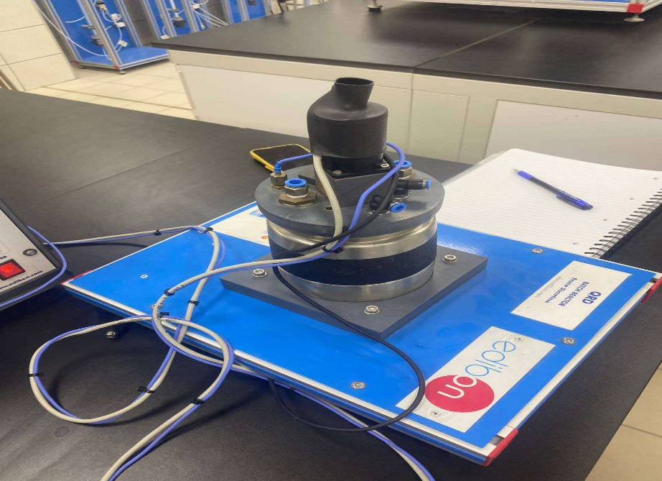

Figure 4 Batch reactor

# Control interface

The illustration above shows the electronic interface used to manage the system. It lets users check and read the temperatures, control the flow rate of each reactant, and easily turn the pumps on and off. The interface also allows users to switch between different temperature sensors for accurate readings and to operate the stirrer for mixing the reactants. Overall, this electronic interface is an important tool for effectively managing different parts of the experiment.

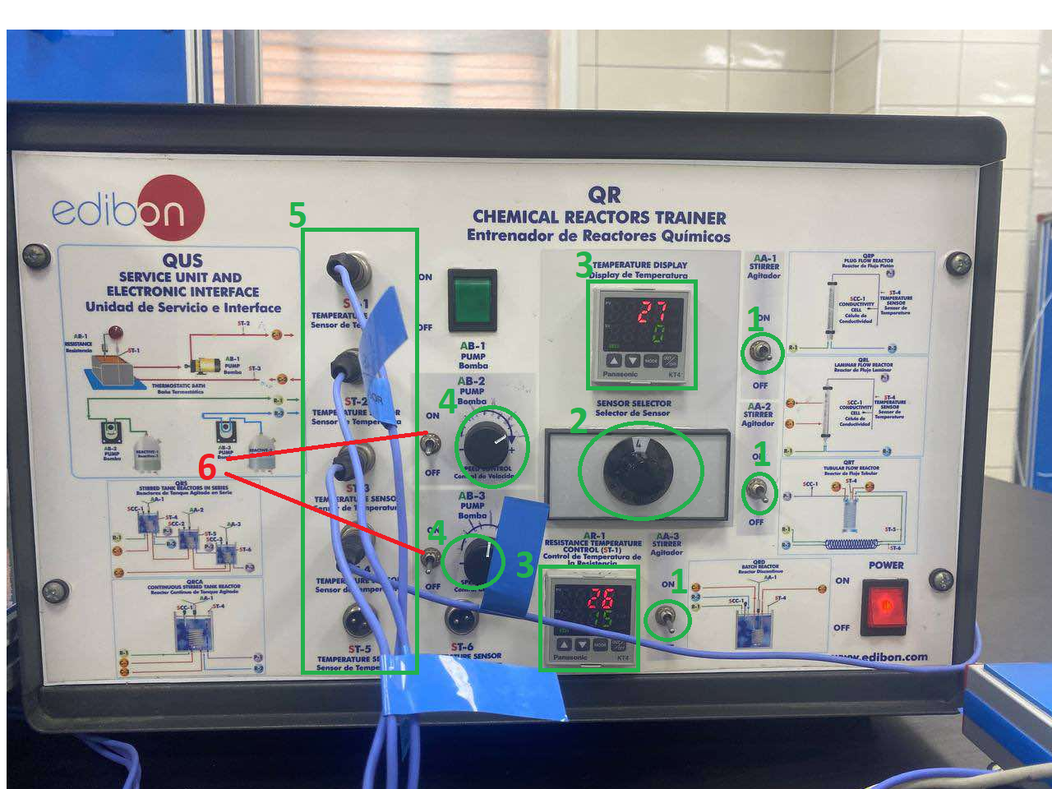

**1.** Agitator switches: These stirrer switches are used to turn the agitators of the reactors (AA-1, AA-2, AA-3) on and off.

**2**. This wheel is used to switch between the temperature sensors.

3. Temperature displays show the readings from the sensors.

4. Row controllers are used to regulate the flow rates of the reactants.

5. Temperature sensors: These connections are used to link the temperature sensor cables to the electronic interface for reading the temperatures.

6. Pump switch: these two switches used to control the operating (on/off) of the pumps (AB-1, AB-3).

# Service unit

The service unit depicted in the figure below resembles a bench that supports the reactors. It is connected to each reactor for conducting experiments and includes several components, such as reactant containers, pumps to move the reactants, and a water container to regulate the temperature inside the reactor and of the reactants. The service unit is linked to the reactors using hoses, which facilitate the transfer of reactants from the service unit to the reactors.

**The components of the service unit include:**

1. Containers for reactants

2. A water tank with a heater

3. Pumps

4. Inlets for the reactants

5. A control board for the heat exchanger

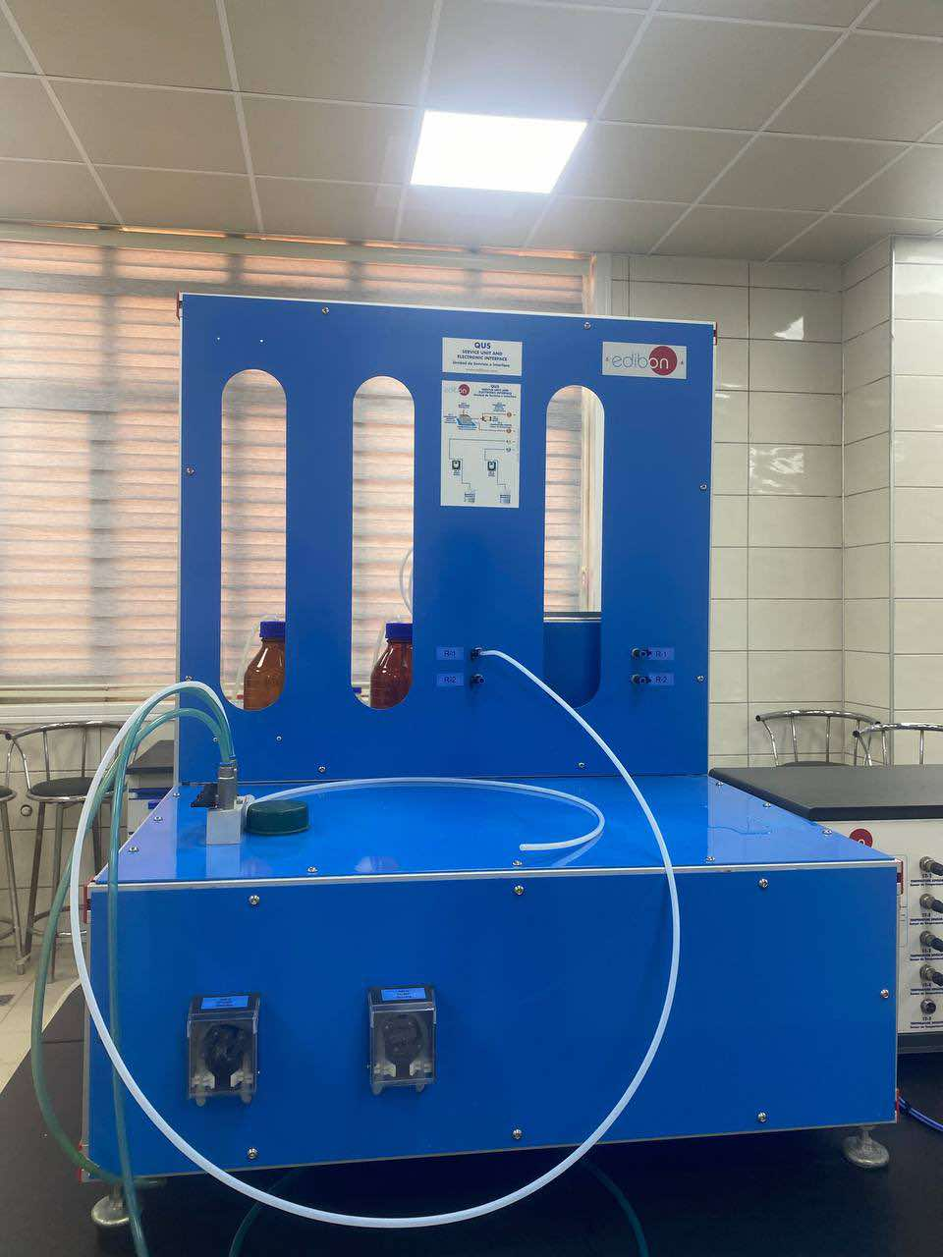

**Discussion**

**Rezhin Rzgar**

**1.What is control interface?**

.In chemical engineering, a control interface refers to the system or method used to monitor and manage processes within a service unit. This interface enables operators to interact with the control systems, providing inputs and receiving feedback on the operational status of various units.

**2**.**Why we use Bath Water?**

A water bath in the context of service units and control interfaces in chemical engineering is a controlled environment used to maintain a specific temperature for experiments or processes

A water bath is used to heat, cool, or maintain the temperature of samples or equipment in a controlled manner**.**

**3.Why we use acetic acid (CH₃COOH) and sodium hydroxide (NaOH)?**

In a control interface and service unit lab, you can use acetic acid (CH₃COOH) and sodium hydroxide (NaOH) to produce sodium acetate (a salt) while measuring conductivity to assess reactor efficiency. Mix CH₃COOH and NaOH in a controlled environment. The reaction produces sodium acetate (CH₃COONa) and water. The control interface can display real-time conductivity data, allowing you to observe how efficiently the reactor converts reactants into products.

**4.Why we should control Flow Rates?**

Controlling flow rates helps avoid excess reactants, reducing waste and lowering production costs, which contributes to overall product quality. By maintaining stable flow rates, variations in temperature and concentration can be minimized, resulting in a more uniform and high-quality product.

**Dhuha Luqman**

**1.What is the aim of the Reactor Lab experiment?**

The objective of this experiment is to establish and evaluate the connection between the service unit and the control interface.

**2. What is an Electronic Interface?**

Answer: An electronic interface is a digital control platform that enables access to data and remote management through standardized protocols. It facilitates secure user authentication and authorization for data exchange with service providers, allowing controlled access to information such as historical usage and real-time data readings

Insight: The electronic interface is fundamental in modern lab setups, enhancing data accessibility and real-time monitoring. By offering automated control, it significantly reduces manual intervention and increases precision.

**3. What are the primary components of the service unit?**

Answer: The service unit includes several essential components, such as reactant containers, a water tank with a built-in heater, pumps, reactant inlets, and a control board that manages the heat exchanger

Insight: These components are critical in maintaining reaction conditions. The water tank ensures stable temperature, while the pumps and inlets provide acontrolled flow of reactants to thereactors. Each component contributes to achieving precise experimental results.

**4. What is the function of the agitator switches on the control interface?**

Answer: The agitator switches are designed to control the stirrer for each reactor (AA-1, AA-2, AA-3), allowing users to activate or deactivate them as necessary to achieve consistent mixing of reactants

Insight: Proper mixing is essential in reactor experiments as it ensures homogeneous reactant distribution, leading to more consistent and reliable reaction outcomes. The control over mixing intensity directly impacts reaction kinetics and overall performance.

**5. How is the temperature monitored and adjusted in this setup?**

Answer: Temperature is monitored through dedicated sensors connected to the interface. The interface provides a temperature wheel that lets users switch between sensors to obtain precise measurements. Additionally, the water tank with a heater helps regulate and maintain a stable temperature throughout the experiment

Insight: Temperature control is a crucial factor in chemical reactions, affecting reaction rates and product formation. This setup ensures accurate temperature readings andallows fortimely adjustments, thus maintaining optimal conditions for experimental accuracy.

You sent

**6. What role does the control interface play in managing the lab experiment?**

Answer: The control interface is central to experiment management, enabling users to monitor temperature, regulate flow rates, and operate both pumps and stirrers. This integrated control mechanism ensures the precision and repeatability of experimental conditions

Insight: By centralizing controls in one interface, this system not only simplifies operations but also minimizes the potential for human error, enhancing safety and efficiency in the laboratory setting.

**Muhammed kazim**

In this experiment, we explored the interconnections between the service unit and the control interface to evaluate the effectiveness of this configuration for managing a chemical reaction setup. The service unit and control interface are key components in reactor design, enabling precise control over critical parameters such as temperature, flow rate, and mixing speed. This setup provides a structured approach to experimental control, with each element fulfilling specific functions to ensure accurate and repeatable results